**EXERCISE 01: Data Source Filter**

**Purpose:** Optimize performance & enforce row-level filtering

**Scenario:**  
Limit all analysis to data from the **West Region** only.

Perform the following steps to complete the exercise:

1. Connect to **Sample-Superstore.xls** and load the **Orders** table**.**

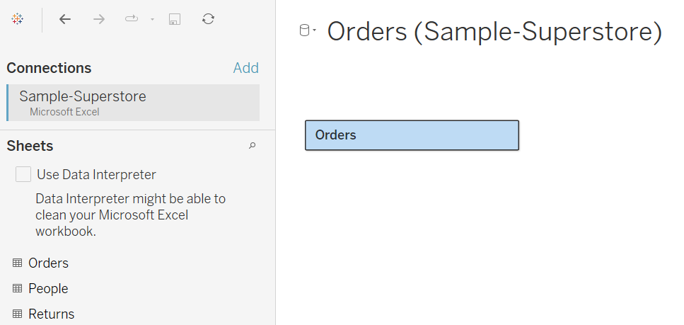

1. On the top right corner, under **Filter**s, Click **Add**.

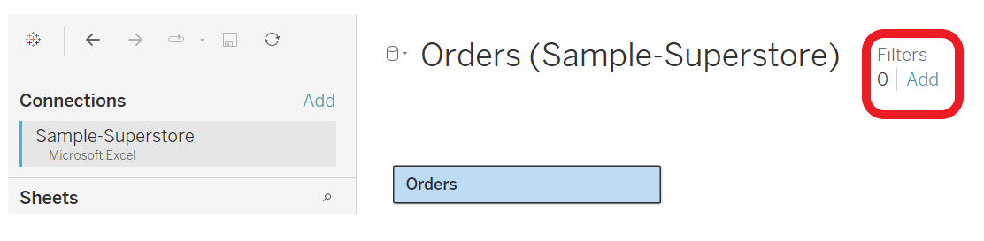

1. On the new window, **Edit Data Source Filters** by clicking **Add** button.

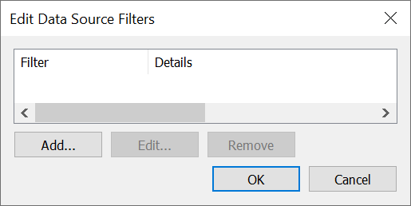

1. Choose Region

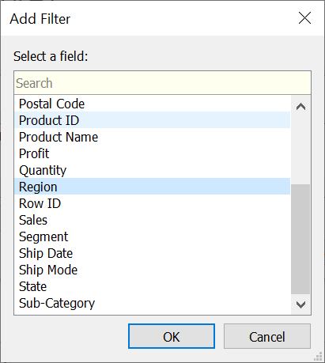

1. Select **East** and **West** (explore other options in the new window). Then click **Ok** and **Ok** again.

***Note: you can add filters as much as you can.***

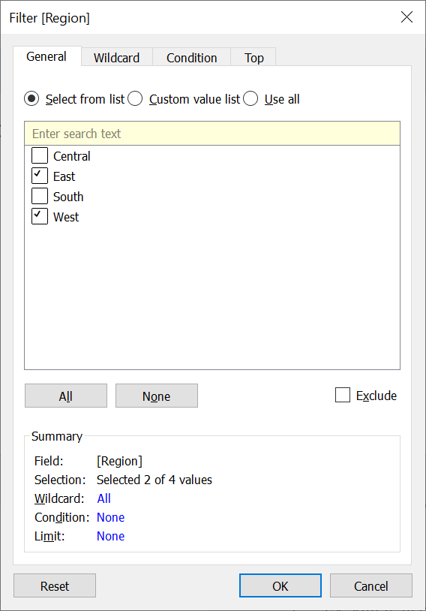

1. Proceed to create visualizations.